Instruction for obtaining regression residuals between self-report and observer-report/objetive measure for self-enhancement constructs

**Step 1**

**Below is an example of a dataset with narcissism, self- and observer-ratings for a certain construct for a group of participant (N=18). In this dataset, narcissism was measured using NPI. Variable names are “NPI” (narcissism), “Self_rating” (self-reported construct), and “Observe_rating” (observer-reported construct) (This variable could become “Objective_measure” if an objective measure instead of observer ratings was used).**

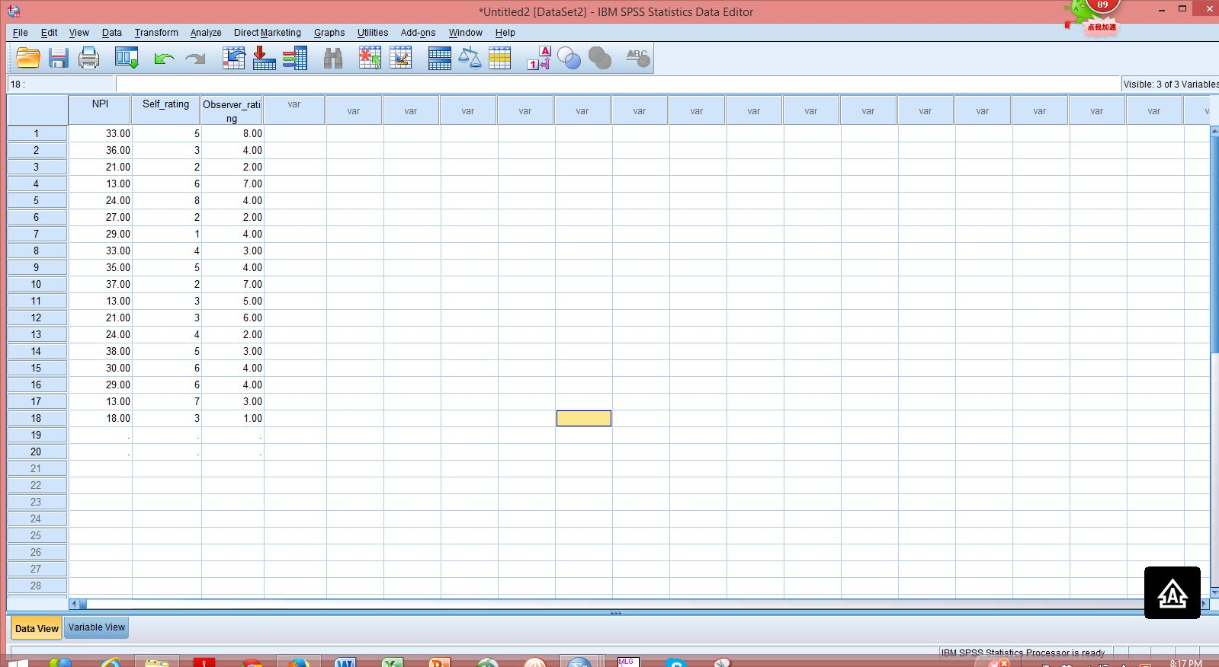

**Step 2**

**To obtain the regression residual between self- and observer-ratings, we need to first regress observer-ratings on self-ratings, which means observer-ratings will be treated as Y (DV), while self-ratings will be treated as X (IV) for the linear regression model.**

**To fit the linear regression model, use the “Analyze” button, choose “Regression” from the first menu showing up, and then choose “Linear…” from the second (the smaller) menu.**

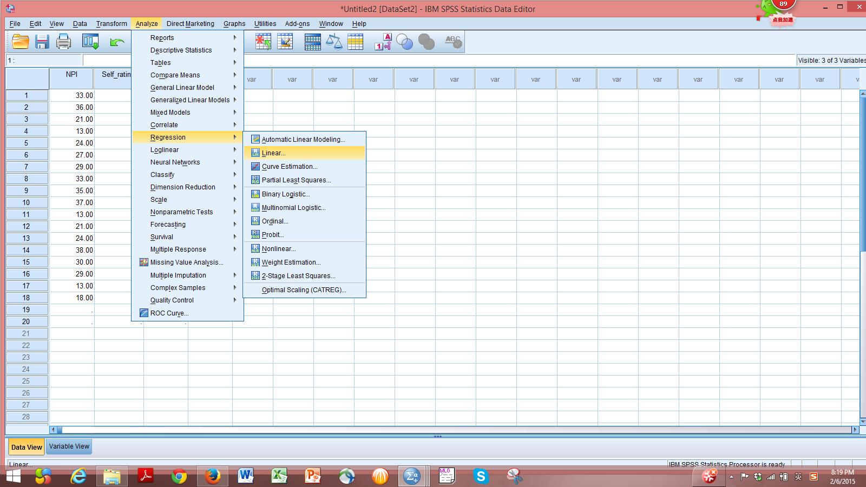

**Step 3**

**Set “Self_rating” as the dependent variable, and “Observer_rating” as the independent variable. Then use the “Statistics…” button on the right side of the “Linear Regression” window for further setup.**

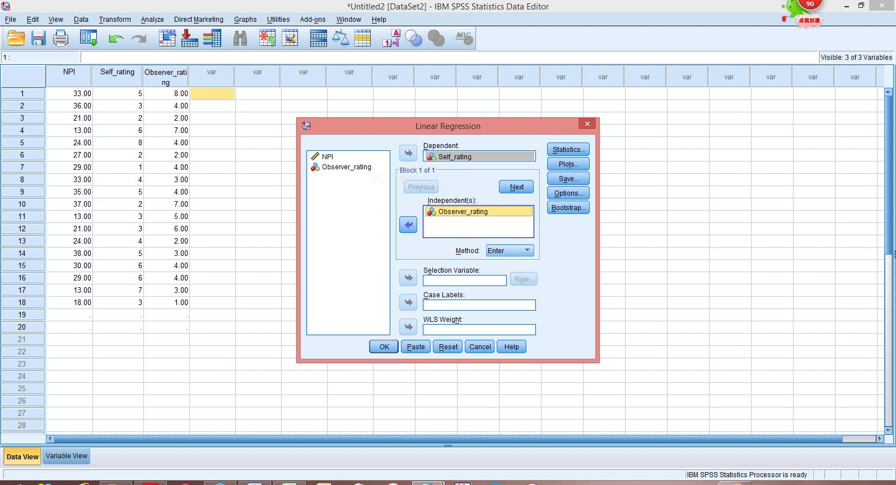

**Step 4**

**As a result of Step 3, a window called “Linear Rregression Statistics” will come out. Check the 2 boxes as shown below in the picture. Then click “Continue”, and get back to the “Linear Regression” window.**

**Then click “Save”.**

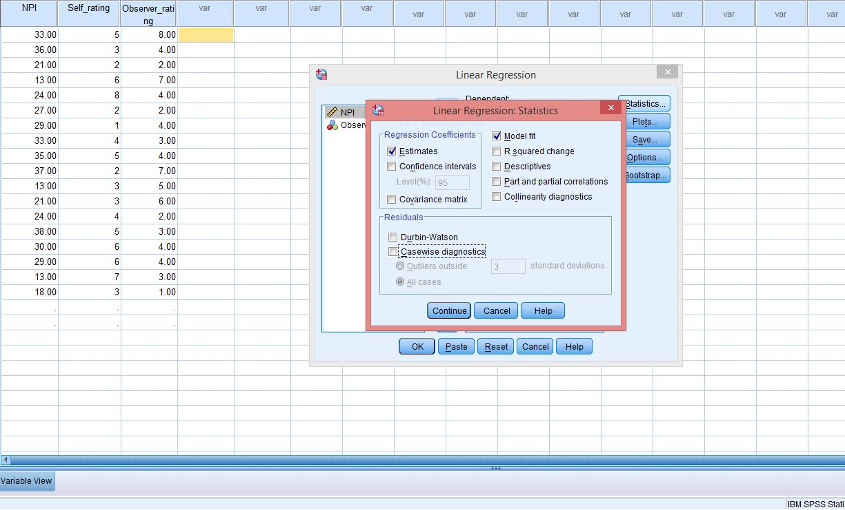



**Step 5**

**Clicking “Save” displays the “Linear Regression Save” window, and then check the box in front of “Standardized” under “Residuals” (as shown in the picture below), which will give you the standardized regression residual between self- and observer-ratings. Then click “Continue”, and get back to the “Linear Regression” window. Then click "OK”.**

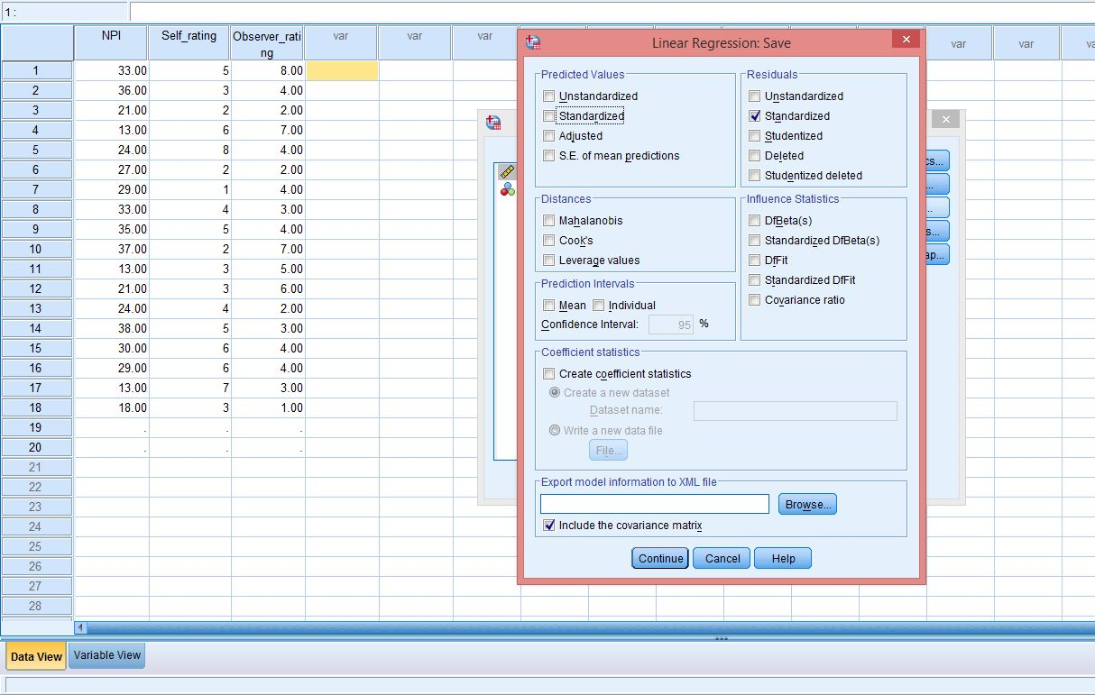



**Step 6**

**Now residuals will appear in the dataset. Obtain the correlation between narcissism and the residuals, and report the correlation, and its significance.**

